**PROJECT 1**

**DEPLOYING WEBSITE ON EC2 INSTANCE:**

1. 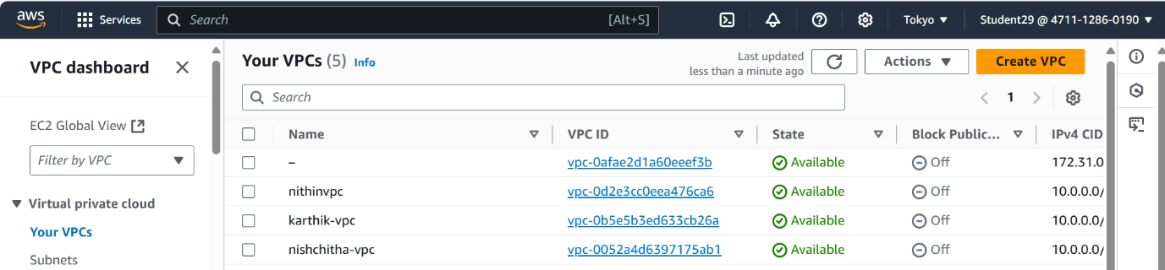Create the vpc

vpc name: nishchitha-vpc

1. Creating the internet gateway.

Name: nishchitha-igw.

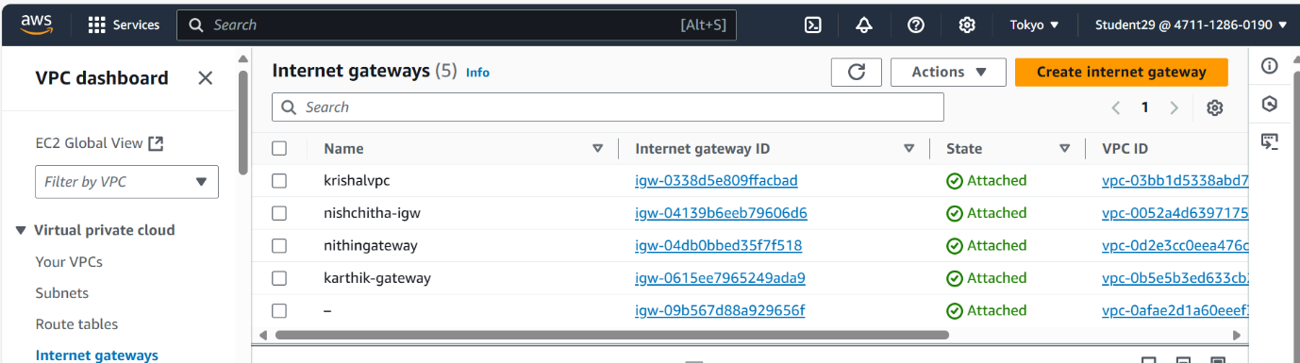Attach the igw to vpc.

1. Creating the subnets.

Creating two public subnets.

1. public subnet 1
2. public subnet 2

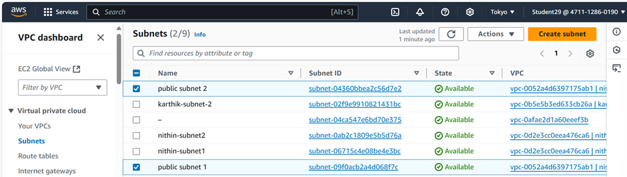

4.Creating the route table.

Routetable name: nishchitha.

Routes- route table -edit routes-add route-igw-save changes.

Subnet association – select route table-edit association-select two public sub nets-save association.

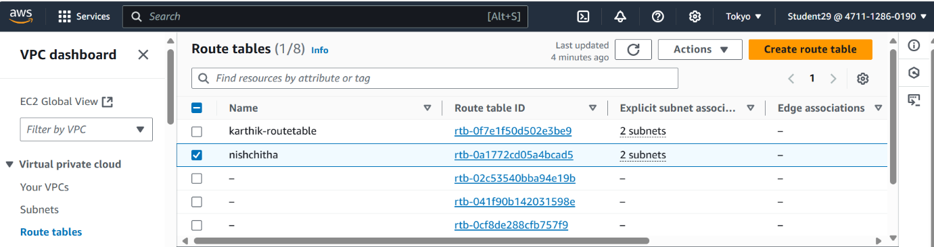

5.Creating the Instance(server).

Server name: nishchitha.

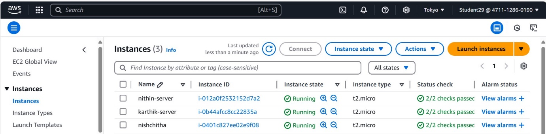

1. Select the server.
2. Connect.
3. Copy its ssh id in the SSH client and paste it in the command promt the follow the following steps..

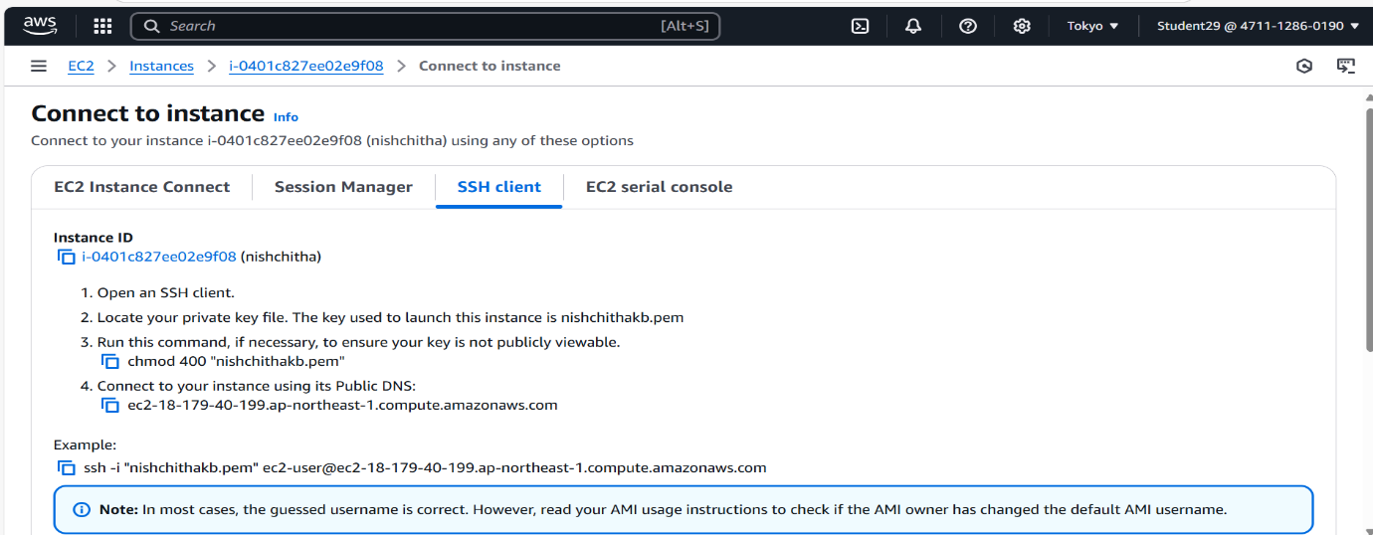

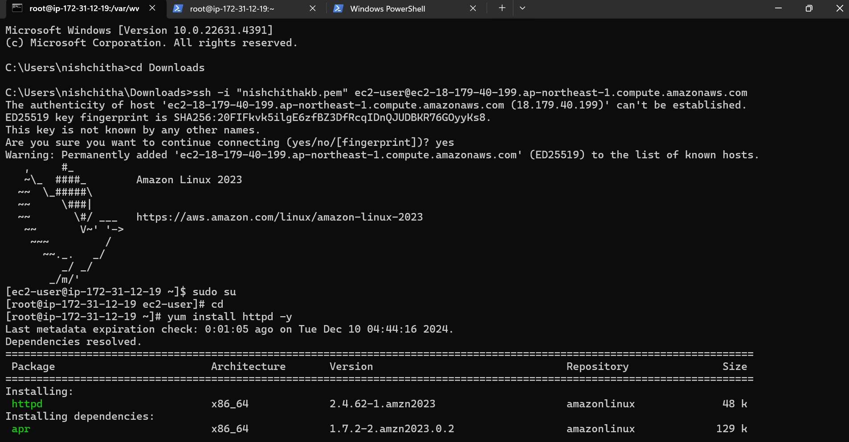

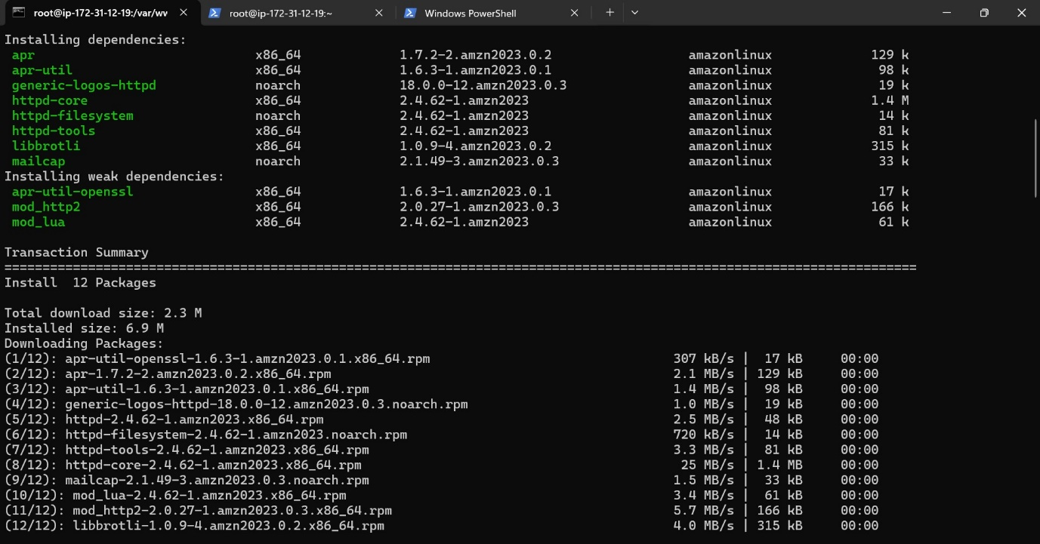

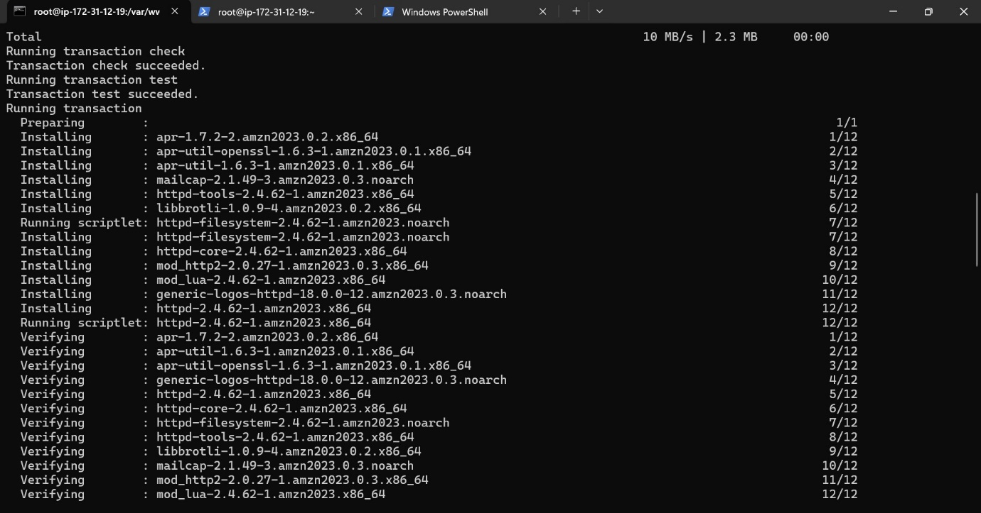

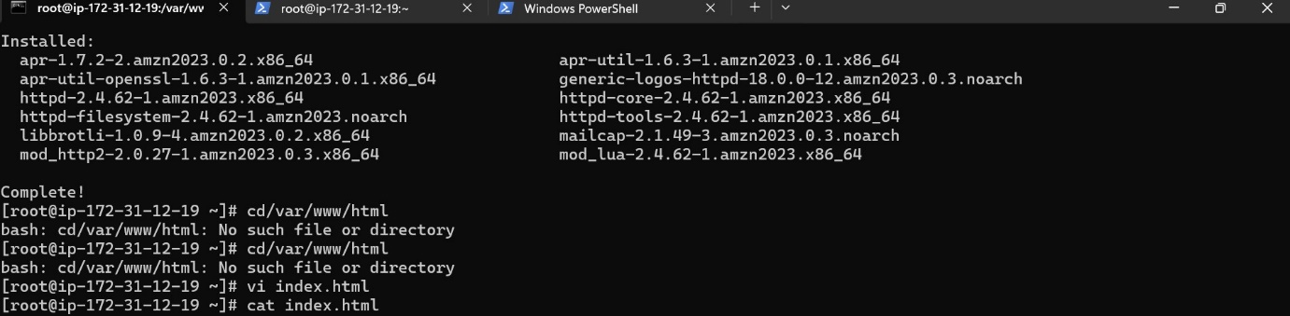

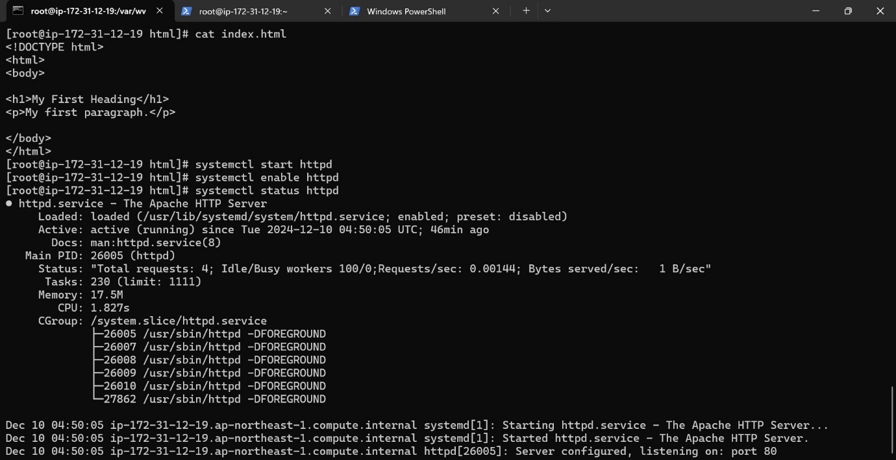

The output:

